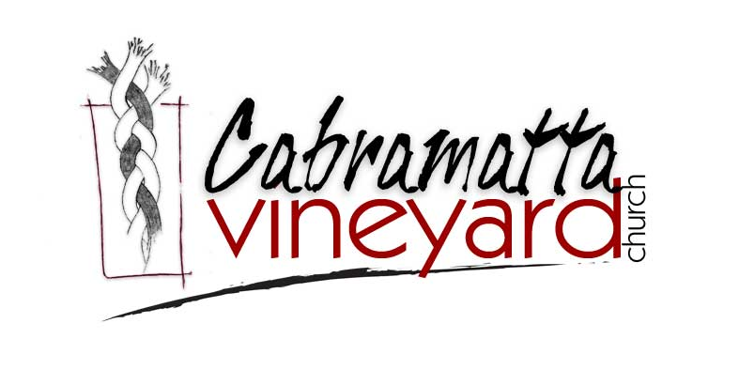
Teacher Authorisation Processes
Verification of WWCC Clearance

In keeping with current child protection legislation, all SRE teachers are required to apply for a WWCC and obtain a clearance number. Approved providers must keep relevant WWCC documents for five years after the employment or engagement has been completed.
Child Protection Training

It is an approved provider’s responsibility to ensure that all SRE teachers have participated in an initial child protection induction and annual update. This is to ensure that SRE teachers are aware of their obligation to advise the principal or workplace manager of concerns about the safety, welfare and wellbeing of children and young people that arise during the course of their work. SRE teachers are mandatory reporters of suspected risk of significant harm and of the procedures for doing so.
Awareness of Department of Education’s Code of Conduct

The Code of Conduct clarifies the standards of behaviour that is expected of all SRE teachers in the performance of their duties. It gives guidance in areas where staff need to make personal and ethical decisions.
Completion of Basic Training
SRE approved providers ensure that all SRE teachers have access to basic training standards. The basic training includes context, knowledge of authorised curriculum, classroom management and the importance of continued professional learning.
Statement in Relation to Specific Crimes

Each approved provider has given an undertaking that any SRE teacher authorised to enter NSW Government schools has not had a criminal conviction for any crime against a minor, a conviction for violence, sexual assault or for providing prohibited drugs

